## RESULTS CT SCAN DATA

Performance metrics for the evaluated CNN models are summarized below:

|  |  |  |  |  |
| --- | --- | --- | --- | --- |
| **Model** | **Accuracy (%)** | **Precision** | **Recall** | **F1-Score** |
| **VGG16 relu** | 0.96 | 0.97 | 0.96 | 0.96 |
| **InceptionV3 relu** | 0.97 | 0.97 | 0.97 | 0.97 |
| **ResNet relu** | 0.99 | 0.99 | 0.99 | 0.99 |
| **MobileNet relu** | 0.95 | 0.94 | 0.95 | 0.94 |
| **Resnet Agumented** | 0.98 | 0.98 | 0.98 | 0.98 |
| **Mobile net Agumented** | 0.96 | 0.96 | 0.96 | 0.96 |
| **Tl_mobile net** | 0.94 | 0.95 | 0.94 | 0.95 |

The confusion matrices for each model are as follows:

## VGG16

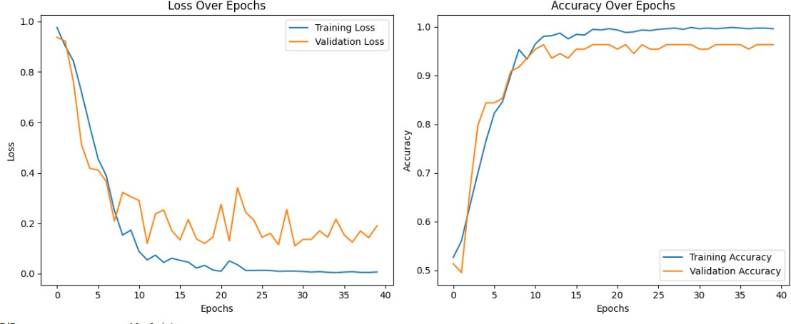

## InceptionV3

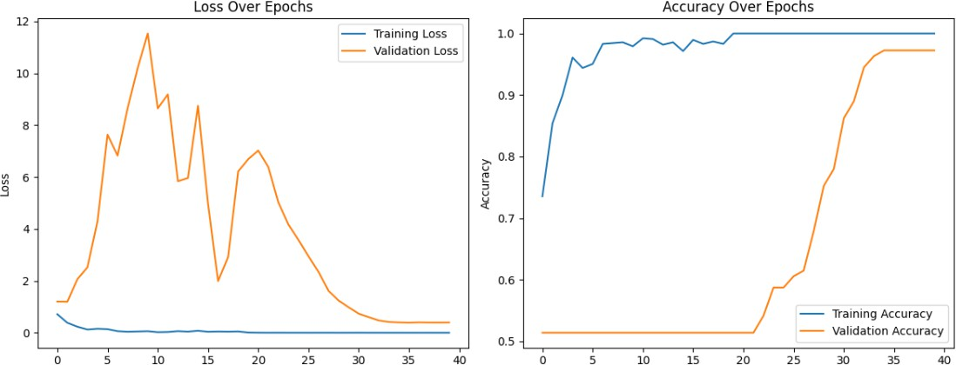

## ResNet

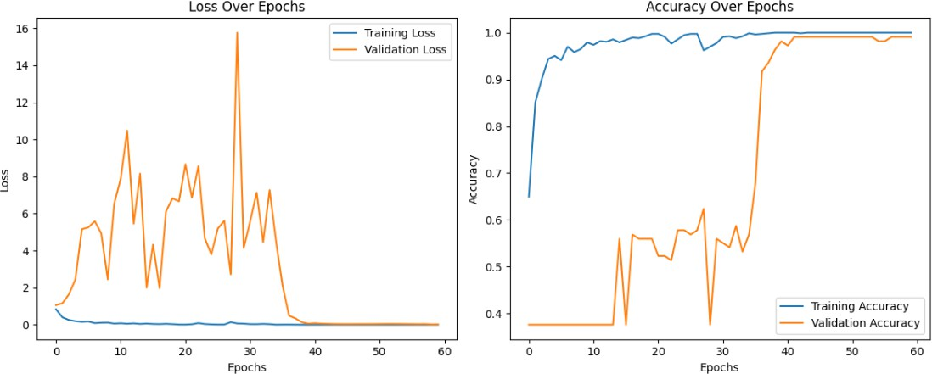

## MobileNet

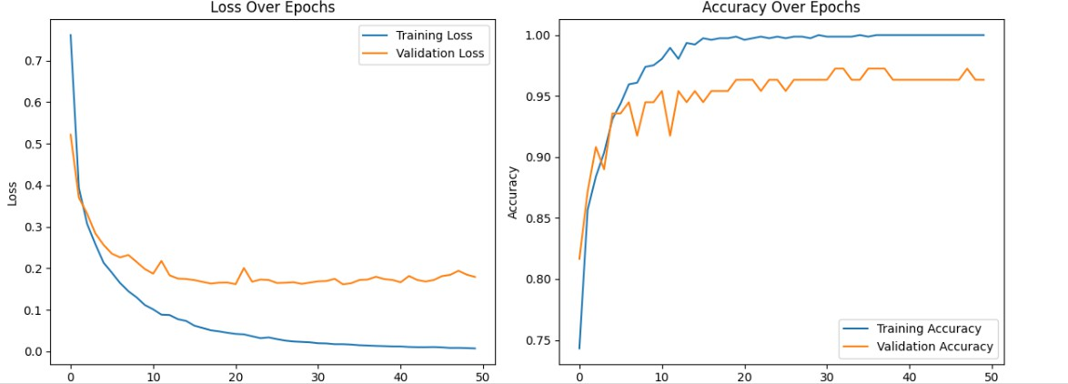

**Resnet relu Augumented**  
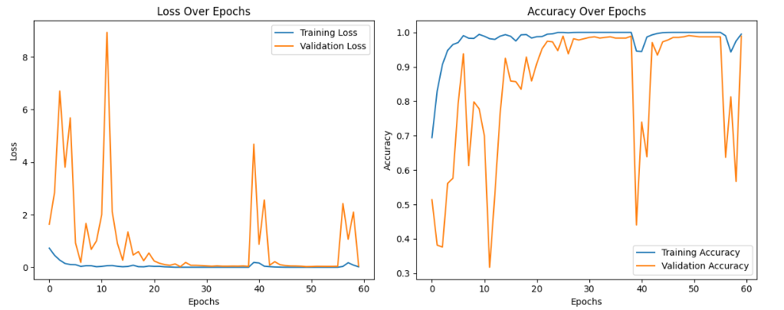

**Mobile net relu Augumented**